Final Year Project Proposal
Department of Software Engineering
N.E.D University of Engineering and Technology

TexChain

Javeria Zafar
SE-040

Maryam Nadeem
SE-026
.
.
- Motivation
Textile and clothing industry is one of the oldest manufacturing industries and is a major contributor in the economic growth of developing countries. However, from past few decades, it has been criticised for its opaque, unsecured and untraceable nature of supply chain. The information is life blood of any supply chain. We plan to make textile industry supply chain transparent for both the brands and manufacturers by developing a platform for Textile industries where the manufacturer will have complete transparency as to from where the raw material enters the whole system. It will cover the origin of raw material entering the whole system through the supplier to ensure the quality as to what claimed by the supplier. It will not only help the manufacturer in buying the material from the supplier through a transparent and a traceable process but also the brands who buy the product from the manufacturers. The manufacturer will also be able to keep track of it’s stock. We plan to craft a system that will help industries use modern technology to take their supply chain management to a whole new level.

- Overview
  - Significance/Importance of project
Quality is the main aspect which is basic need of textile industries. Now imagine if a new industry enters the market which does not know about suppliers integrity with supplying the materials because of zero trust than how that industry will be able to buy materials and goods from that supplier? How come a particular brand which is new in the market will be assured or build confidence to trust multiple manufacturing industries around them? So our system aims at making the life easier for both the actors by enforcing a technology which could build trust across the system actors involved.
.
  - Description of project
People especially millennial tend to distrust the spurious claim of sustainability and so consumers can make or break any event. Huge firms’ selling point has now become the transparency in their supply chain. In this project we add the blockchain technology. As reported by Forbes, Blockchain implementation will facilitate more intelligent business processes because the trust would be distributed, and the processes would be truly transparent. Brands will have to think ahead and position themselves to integrate with the technology. That’s why brands and manufacturers need to give their consumers what they demand. And consumers are demanding transparency and sustainability to continue with brands. Many apparel brands are transforming their business model from linear to circular. They are minimizing their waste and disposing of them properly. Moreover it helps in managing the stocks for the suppliers.
2.3 Background of project
In the past, lack of transparency in a company’s supply chain was seemed as a competitive advantage. Businesses wanted to keep insight into their suppliers and manufactures as opaque as possible so that if no one knew where the supplies were coming from, no one could build identical apparel. And this thinking extended to customers, out of sight meant out of mind when it came to worries about ethical sourcing and manufacturing in the textile industry. We visited textile industry to ask them about the problem we identified in the supplychain. Through requirement gathering and searching across internet we came across the decision to implement this idea to maximize transparency to make it more convenient and less exhaustive to find a right supplier or manufacturer to work with.
- Salient Features
      - Basic Goal:
The system will use blockchain to implement transparency for both brands and manufacturers plus for manufacturers a platform to keep track of their stock. It will be different from ERP systems usually used by the industry.
      - Functionalities:
The system will contain the databases and transactions for the material coming from the supplier and checking it through QR code. It will be installed at manufacturer side and making disabled few options for the brand and the supplier. We will use blockchain which can fetch any information starting with suppliers, then manufacturers, shippers, and retailers within seconds. Moreover, Sustainability and compliance of goods can also be tracked through information from the blockchain on the raw material and manufacturing processes used to make it. Consumers can now scan the tag and discover the history of any garment.
      - Utilization:
This system will save time and money with a user-friendly interface.

- Project Planning
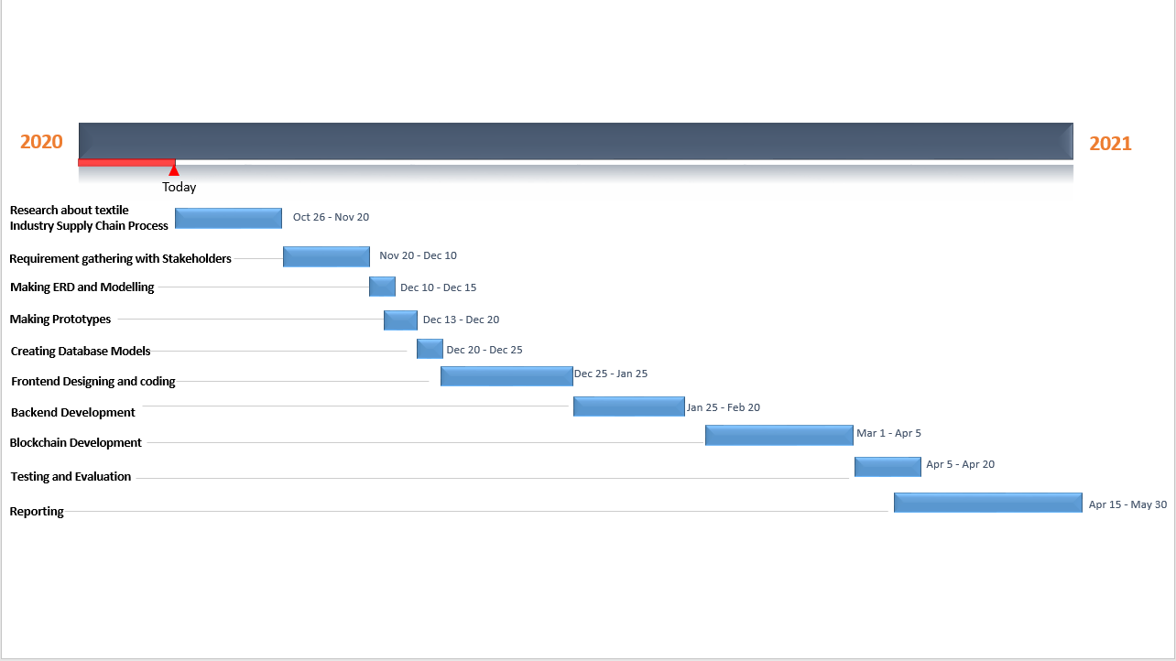
- Required Hardware and Software
Hardware:
Smartphone and pc
Software:
IDE:
VS Code
LANGUAGES:
Node.js
React.js
Ethereum
MySql
Management :
Trello
Github
Azure Devops

- Diagrammatic Representation of the Overall System
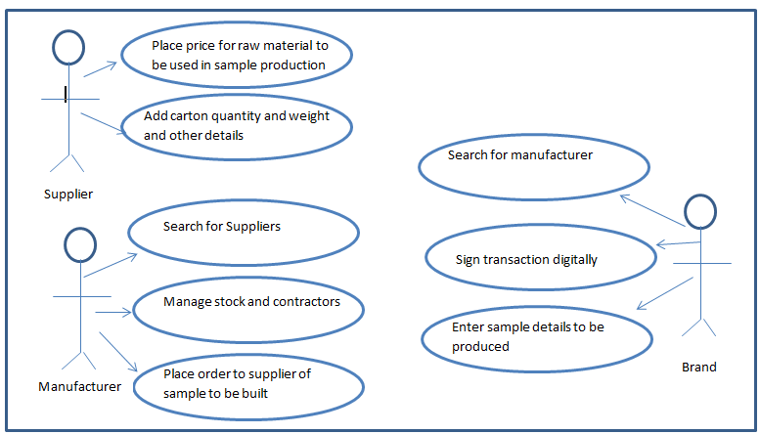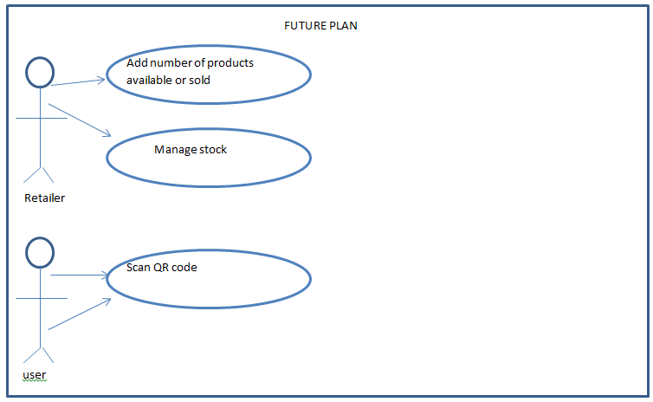
- References
- https://www.forbes.com/sites/samantharadocchia/2018/06/27/altering-the-apparel-industry-how-the-blockchain-is-changing-fashion/#6361cb6229fb
- https://www.fibre2fashion.com/industry-article/8428/blockchain-is-reshaping-the-world-of-textile-apparel
- https://www.ukessays.com/essays/business/report-on-supply-chain-management-in-textile-industry-of-pakistan-business-essay.php

